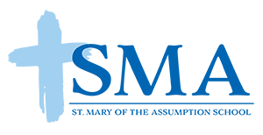

St. Mary’s Day of Giving

Dear Neighbor,
My name is _________________________ and I am a member of the 5th/6th Science Olympiad Team at St. Mary of the Assumption School. Our parish and school community is having a Day of Giving where students and parishioners will be participating in a variety of service projects throughout Lake County. The Science Olympiad Team is collecting cases of bottled water to support Project Hope, a non-profit that provides emergency shelter, care, and ongoing guidance to the homeless in Lake County. Please consider donating a case of water to support Project Hope.

Please leave the case of water on your front porch between 11 a.m. and 1 p.m. on Sunday, April 22nd and I will be around to pick it up. We intend to provide Project Hope with enough bottled water to meet their needs for weeks and months to come. Thank you for your generosity!

